**Lab 14**

To complete this exercise, you need to have lab 13 completed.

Make a copy of Lab13 Exercise 2 and rename this to Lab 14 JOINED ONETOMANY

Use suitable table names for this exercise.

This program already has the following tables

EMPLOYEE TABLE

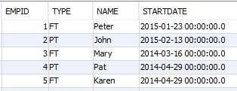

FULLTIMEEMPLOYEE TABLE

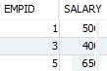

PARTTIMEEMPLOYEE TABLE



Use the sample program on composition as a guide for this exercise

Add a new table called Contact and populate it with the data shown below:

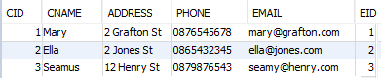

You will also need to create a Contact entity class with 5 members as shown above.

Create constructor and getter and setter methods

Using JPA annotations define the following mapping

Employee – Contact is a One-To-Many mapping

An employee can have one or more contacts

Add the following 3 menu options to the test class and write Java code to get these menu options working:

